# Introduction

This study will provide a numerical investigation of the same experiments performed by Patrick in 1987 [1] and So and Mellor in 1972 [2]. These studies were interested in the separation of boundary layers as they propagate over curved surfaces, or like, or even experience deceleration caused by interacting shocks [1: ch 1]. This behavior is referred to as an Adverse Pressure Gradient [3: ch 6] (APG). This will cause the following effects that are of interest to those studying turbulence:

1. The shear behavior at the wall changes since the inflection is negative (i.e.: ) [4: ch 10]. At the separation point, the shear is zero (i.e.: at the separation point) [4: ch 10].
2. The transport behavior distribution will change throughout the bounded flow. This will affect the modeling of these flow behaviors since the diffusion of momentum, energy, species, etc., will be altered [3: ch 6]. This aspect is of the highest interest in this study.
3. There will be, for compressible flow near or above the sonic flow conditions, interactions with shocks [1: ch 1]. This study will focus on incompressible flow to separate the turbulent behavior from the incompressible.

## Application

This study is important to contribute to the knowledge of fluid mechanics as applied to rotating machinery [1, 2], rocket nozzles, aircraft airfoils, and wall-bounded flows [5: sec. 1]. When working through airfoils of multiple applications, and likely non-airfoil bounded flows, this separation issue determines the bounds of the operating envelope for engineered components [1: ch 1].

Figure 1. Illustration of Flow Separation on an Airfoil. Originally Figure 1-1 from [1].

## Analytical Data and Correlations

There are multiple ways to compensate for behavior changes caused by separation of the boundary layer.

1. A diagram of a function

   Description automatically generatedThe eddy viscosity of the flow can be modified by the separation of the flow [3: ch 6]. This will effectively change the diffusivity of the momentum in the bounded flow [6: ch 4]. This change in one diffusivity through viscosity raises the question of how the diffusivity of other scalars like temperature will change, altering the turbulent Prandtl number away from the Reynolds analogy [7], reportedly more determined by the wall pressure than viscosity [8, 9], illustrated in Figure 2.

Figure 2. Relation of Pressure Gradient and Reynolds Analogy Factor. Reynolds Analogy Factor Calculated using the methods in [9].

1. The mixing length can change the overall behavior of the flow [3: ch 6]. There are multiple models and correlations that can be used. White describes simple empirical models [3: ch 6] and Simpson provides more complex ones with a comparison to canonical data [5: sec 5].
2. Higher order models like the Reynolds-Averaged Navier-Stokes (RANS) models can form a Partial Differential Equation method for finding the same alterations to provide a way to calculate the transport of these scalars through the flow.

### Patrick’s Study

This study that is being emulated in CFD was a wind tunnel test of a flat plate that is in a wind tunnel that was owned and operated by United Technologies Research Center in East Hartford, Connecticut, and supported by NASA’s Lewis Research Center, now Glenn Research Center. Rather than going into depth on the tunnel that is illustrated in Figure 3 and described in detail in [1], some highlights of the design:

1. The temperature and air quality are controlled by the heat exchanger and HEPA filter, respectively.
2. The boundary layer is tripped from a laminar state to a developing turbulent state by the bar shown in Detail A. This will control the boundary layer as it travels into the test section.
3. The lower diverging wall is adjustable and has a boundary layer scoop to remove the effects of a duct flow to study purely the boundary layer on the top surface. The second scoop section was not used.

Figure 3. Wind Tunnel Diagram. Originally Figure 3-2 from [1].

1. The test section is equipped with the following instrumentation:

Table 1. The Test Section Top Surface Instrumentation.

|  |  |
| --- | --- |
| Quantity | Instrumentation |
| 120 | Static Pressure Taps |
| 55 | 0.63cm dia probe ports |

Figure 4. Top Plate Instrumentation Placement. Originally Figure 3-7 from [1].

Table 2. The Test Section Bottom Surface Instrumentation.

|  |  |
| --- | --- |
| Quantity | Instrumentation |
| 20 | Static Pressure Taps |
| 20 | 0.63cm dia probe ports |

Figure 5. Diverging Duct Instrumentation Placement. Originally Figure 3-6 from [1]. Probing ports are along the centerline of tunnel.

1. The instrumentation could be either hot wire or total pressure probes.
2. A close-up of a structure

   Description automatically generatedLaser velocimetry measures the movement of the flow via suspended titanium dioxide powder.
3. The flow on the test flat plate was visualized via “tuft trees”, which are tubing manifolds that inject a “red low-viscosity fluid”.
4. The flow was measured as a two-dimensional (2D) flow with the following flow parameters calculated:

Figure 6. Tuft Trees. Originally Figure 4-3 from [1].

Patrick and colleagues provide much data on the separated flow over the top flat plate, illustrated in Figure 7.

Figure 7. Flow Profile Through Test Tunnel. Originally Figure 5-3 from [1].

### So and Mellor’s Study

This study provides a test of a separating over the flow over a curved surface, illustrated in Figure 8, which is a more explicit production of the APG condition. The study focuses on the separating flow setting since that is the point of the study.

Figure 8. So and Mellor Test Stand Schematic. Originally Figure 1 in [2].

Figure 9. Convex Test Section from So and Mellor. Originally Figure 3 from [2].

Figure 10. Concave Test Section. Originally Figure 4 from [2].

The geometry is determined by the simple flat plate boundary layer thickness relation that So and Mellor identify, described in Equation 1. This known thickness then feeds into a constant value of the ratio of boundary layer thickness to curvature in Equation 2.

Equation 1. Simple Flat Plate Turbulent Boundary Layer Thickness Relation.

Equation 2. Curvature Ratio Values.

So and Mellor use some of the same instrumentation from a high level as Patrick to understand the flow, although So and Mellor are able to capture a three dimensional (3D) understanding of the flow around their bend since the hot wires are allowed to rotate by a dial device applied to that instrumentation. The locations of the instrumentation around the bend are shown in Figure 11.

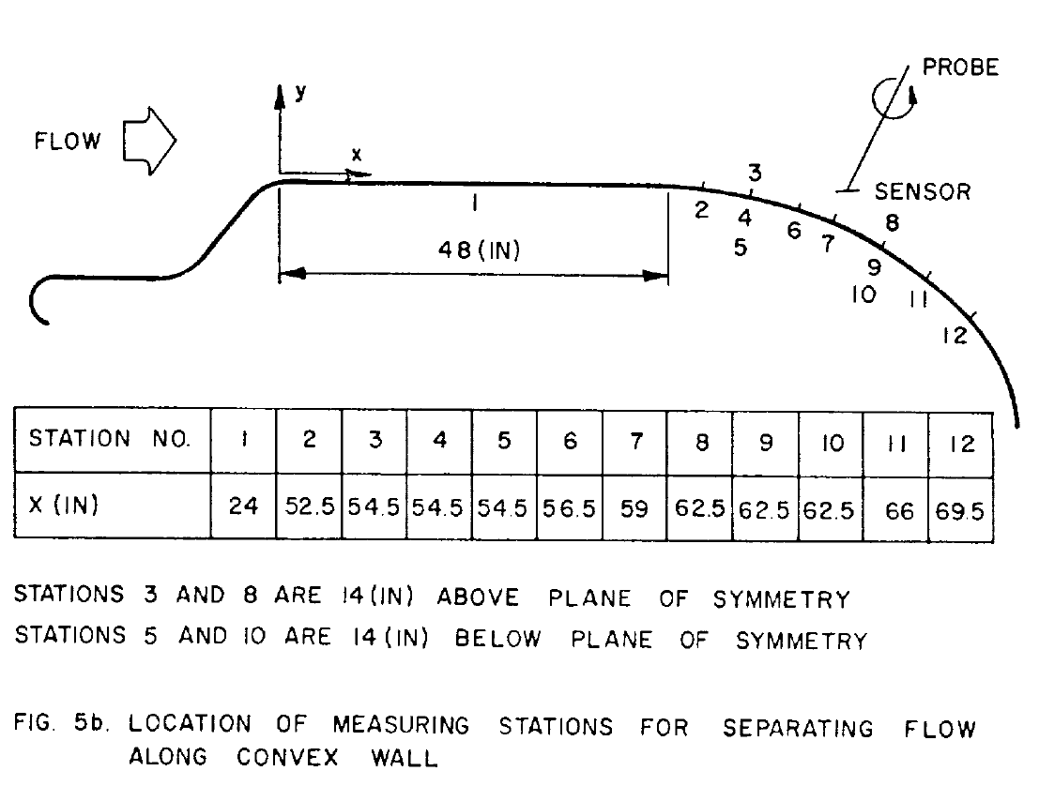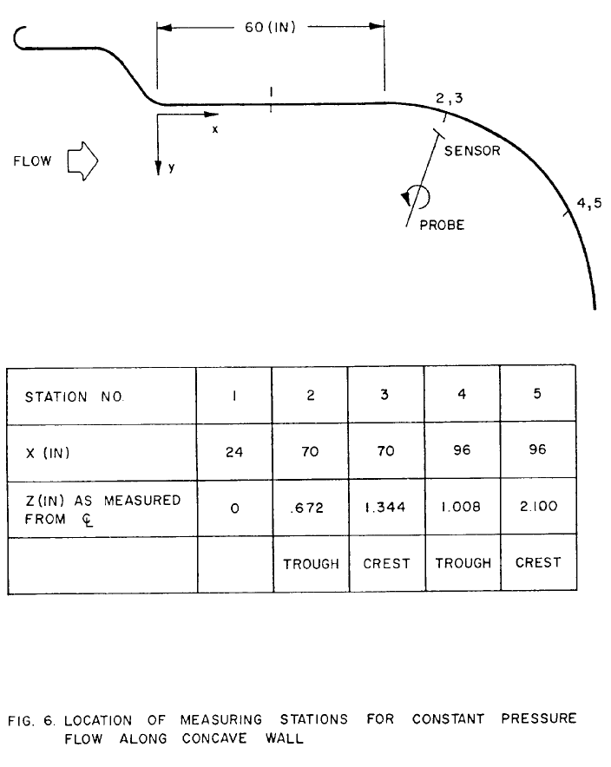

(a)

(b)

Figure 11. Instrumentation Placement. Originally Figures 5(b) and 6 from [2].

# Works Cited

1. Patrick, W. P. (1987). *Flowfield Measurements in a Separated and Reattached Flat Plate Turbulent Boundary Layer.* NASA CR-4052, Contract NAS3-22770, NASA Lewis Research Center.
2. So, R. M. C. and Mellor, G. L. (1972). *An Experimental Investigation of Turbulent Boundary Layers Along Curved Surfaces.* NASA CR-1940, Contract NGR 31-001-074, NASA Lewis Research Center.
3. White, F. M. and Majdalani, J. (2022). Viscous Fluid Flow. McGraw-Hill, Fourth Edition.
4. Kundu, P. K., Cohen, I. M., and Dowling, D. R. (2012). Fluid Mechanics. AP Press., Sixth Edition.
5. Simpson, R. L., Chew, Y.-T., and Shivaprasad, B. G. (1981). *The structure of a separating turbulent boundary layer. Part 1. Mean flow and Reynolds stresses.* Journal of Fluid Mechanics, vol 113, pgs 23-51.
6. Pope, S. B. (2003). Turbulent Flows. Cambridge University Press.
7. Kiselev, N. A., Malastowski, N. S., Zditovets, A. G., and Vinogradov, Yu A. (2024). *Reynolds analogy violation for a compressible turbulent boundary layer with pressure gradient in a small-size supersonic slot channel.* International Journal of Thermal Sciences, vol 200.
8. Martin, M. P. and Priebe, S. (2021). *Turbulence in a hypersonic compression ramp flow.* Physics Review of Fluids, vol 6.
9. So, R. M. C. (1993). *Pressure gradient effects on Reynolds analogy for constant property equilibrium turbulent boundary layers.* International Journal of Heat Mass Transfer, vol 37, no 1, pgs 27-41.